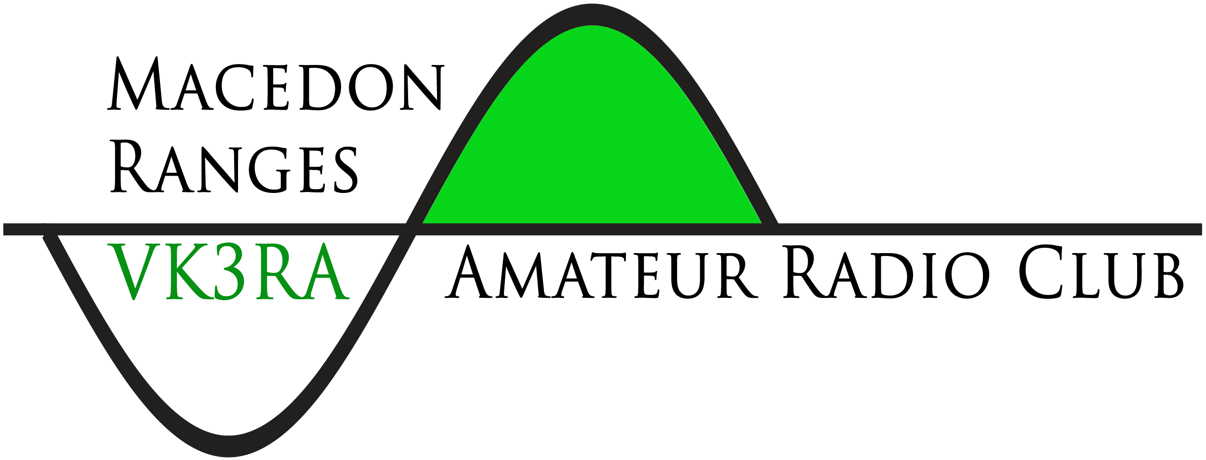
MACEDON RANGES AMATEUR RADIO CLUB INC.
(Incorporated Associations Number - A0055632V)

Application for Membership

Name: ________________________________________________________________________

Callsign: _______________________________ WIA Member (Optional) Yes / No

Occupation/Interests:_______________________________________________________________

Mailing Address: _______________________________________________________________

City: __________________________________ State: ___________ Postcode: ______________

Phone: ________________________________ Mobile: ________________________________

Email: ________________________________________________________________________

I wish to become a (please circle one) Full / Family / Concession / Student / Associate (non voting)
member of the Macedon Ranges Amateur Radio Club Inc.

In the event of my admission as a member:
I agree to abide by the rules of the association and support the statement of purposes.

Signed ____________________________________________________Date _______________

Completed form to be given to a committee member or posted to:
Macedon Ranges Amateur Radio Club Inc, PO Box 10, Gisborne, Vic, 3437

MRARC Membership Fees:  Family $50  Full $40  Concession $35  Student $35  Associate $35  Amount enclosed: $______ | Please mail cheques to:  Macedon Ranges Amateur Radio Club Inc.  PO Box 10, Gisborne, VIC 3437  or  EFT: Bendigo Bank  BSB: 633 000  Acc #: 139 709 539  Please use your callsign or name as the reference.

Web site: www.mrarc.org.au Email: membership@mrarc.org.au
Admin only Accepted Date [ ] Membership records updated [ ]
Treasurer’s records updated [ ] Receipt Number & Date [ - ]

